CS 255 System Design Document Template

This template lays out all the different sections that you need to complete for Project Two. Each section has guidance to prompt your thinking. You will need to continually reference the interview transcript as you work to make sure that you are addressing your client’s needs. There is no required length for the final document. Instead the goal is to complete each section based on what your client’s needs are. Remove this note when you are finished, and replace all bracketed text with the relevant information.

UML Diagrams

UML Use Case Diagram
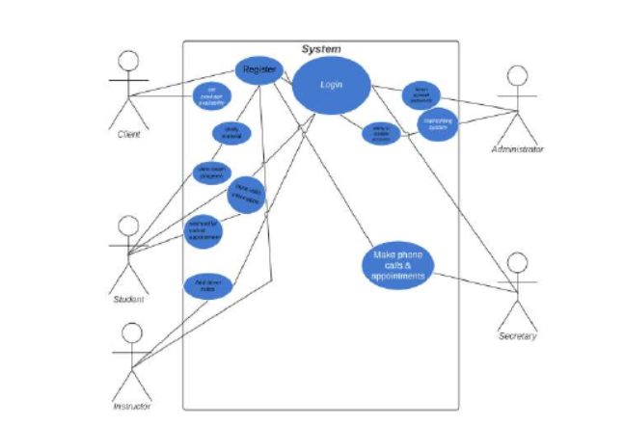

UML Activity Diagrams
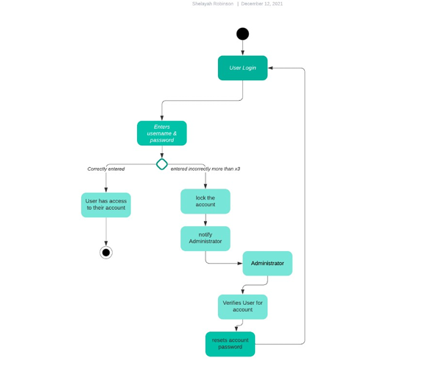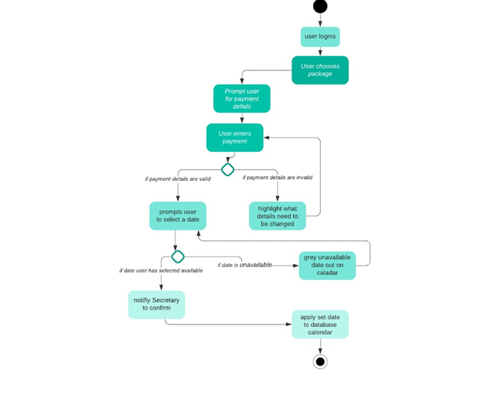

UML Sequence Diagram
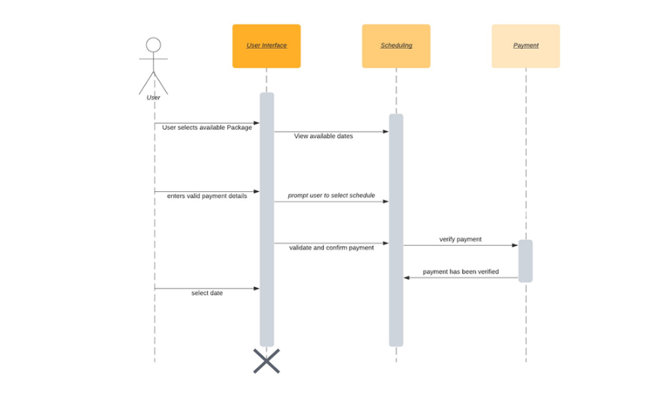

UML Class Diagram
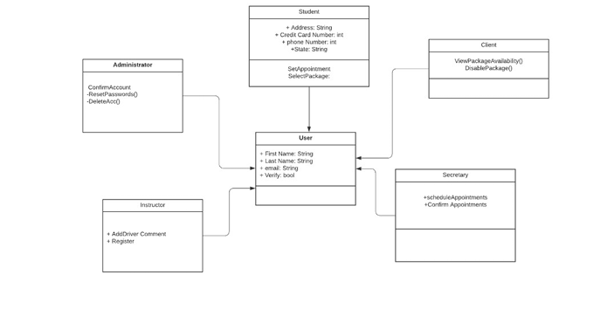

Technical Requirements
Based on the diagrams created for the DriverPass system, the following technical requirements are necessary to support the system’s functionality:
- Secure user authentication, including login validation and password reset functionality
- Role-based access control to manage user permissions (student, instructor, administrator)
- Payment processing validation to securely verify and authorize transactions
- Input validation to ensure accurate and secure user-submitted data
- Administrative controls to enable or disable lesson packages as needed
- System logging and request validation to track user actions and prevent unauthorized changes
These requirements ensure that the system operates securely, reliably, and efficiently while supporting the core business functions identified in the design diagrams.

